Coursework

**Module:**

**Mobile Applications Development**

**SET08114**

**Karol Pasierb**

**40270305**

Software Engineering – Year 2

**Financial Ninja**

# Introduction

## Overview

Idea behind this application was to create a quiz to test financial awareness. After each completion of the quiz there would be points rewarded depending on answers and the results would be presented. There are 6 levels for the path to become true financial ninja. Each of them describes current status achieved and is a result of financial decisions. Therefore, some specific question could check on which level the user might be. Generally whole concept is much more complicated. But the basics are the same and this quiz could help some people get motivated and inspired to constantly grow, learn and expand financially.

However, during the development, this idea was abandoned for more inspirational one. The decision was made, that the quiz could not be as engaging and interesting as thought at the beginning. The new idea was based on taking inspiration from someone else’s successes and their views on certain things. New idea for the application was to build the list of inspirational quotes that would be constantly displayed for certain period of time on the rotational basis. Most of the content was already designed and operational for the previous idea purposes, therefore the change did not impose many problems.

## Inspiration Background

This application is inspired by the Polish book “Financial Ninja” by Michał Szafrański 1 and “Total Money Makeover” by Dave Ramsey 4. These books are guides for personal finance and a good description of the path everyone should follow. A lot of valuable knowledge could be gained from them: tips about how to run home budget, how to beat debts and to successfully avoid them, a lot of general tips about finances and how to plan future. This application could be nice addition to the books. This idea was abandoned as the new concept fits even better to the financial awareness growth. With a lot of great inspirational quotes displayed on the phone, user will be constantly reminded to stay on track and don’t give up. There could be a possibility of expanding this application into something bigger, like a platform for the books’ users, some sort of a tool supporting reading similar books and articles, etc. This project could be a great platform for likely minded people.

# Software Design

## Wireframes 2

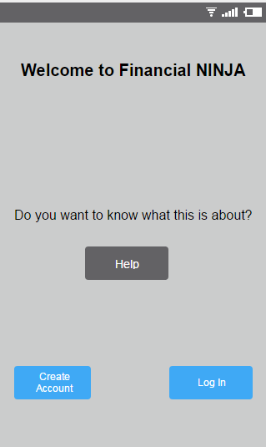 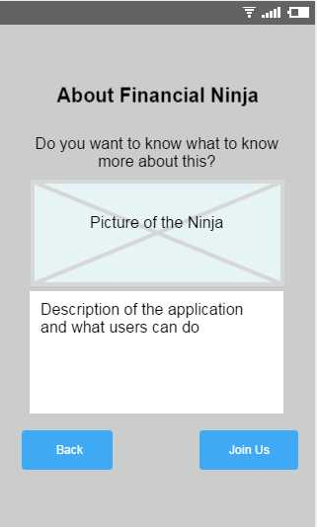

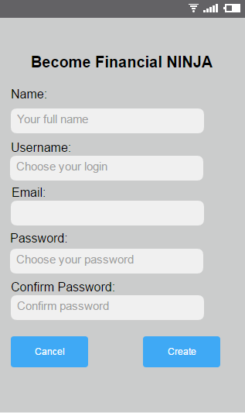 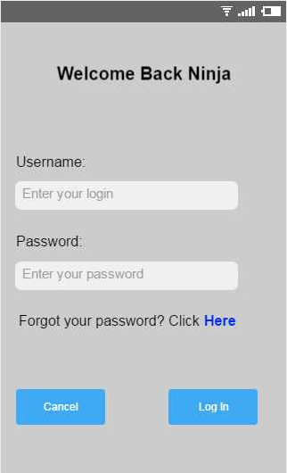

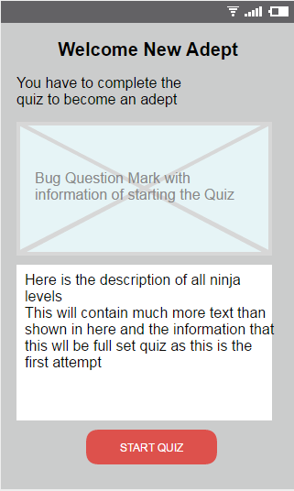 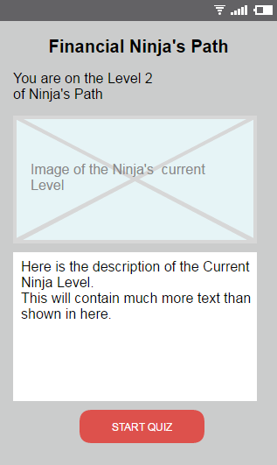

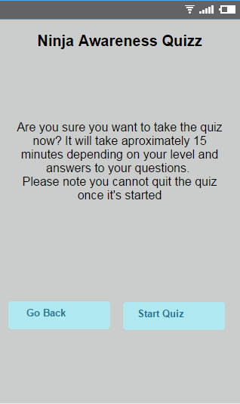 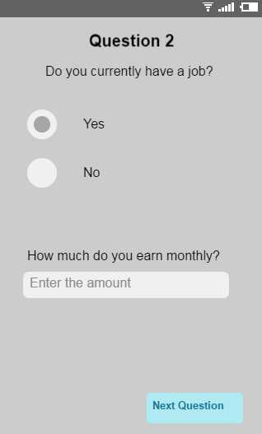

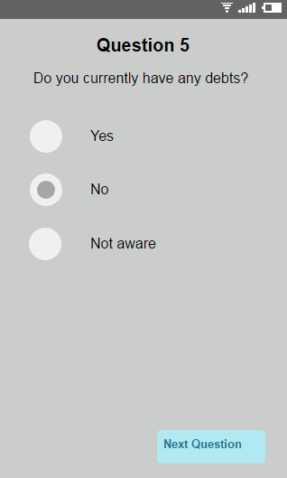 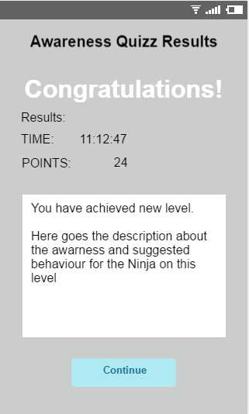

## Brief and Critical Review

From the main window user can create account, log in or read about the app. Read about page will show user the description of an app and then user can either go back or create new account. On creating account, user need to choose log in, give email address, create and confirm password. Account details will be stored in a database on a server. There is also an option to explore account creation with Gmail if that would be easy to do. Log in screen simply authorizes access to an app with the appropriate credentials.

Next, user is transferred to the welcome home screen that displays the reminder about the Ninja’s path and some motivational content. Then user opens main home page where quotes are being displayed and they change on the time rotation basis. This screen starts the constant notification that cannot be dismissed. Notification contains the quote and the time left to display it. If user quits the app, tap on the notification will resume the main home screen. The time can be set below when user chooses settings. As soon as the new time is set the notification restarts with the new time.

There is a button to add quotes and this can be done as many times as user wishes. Each successful submission shows the toast notification and erases the text boxes so the user can know the action was performed successfully. At the moment, all the quotes are sent to the database and stored there. However, all the quotes that application displays to the user are stored locally. This means that on the fresh installation of the app there will be no quotes to display. This is one of the current biggest disadvantages of the app. Local files are serialized and accessible only for this application. There is no other use for those files and they cannot be used anywhere else. Much better option to focus on for further updates would be to store all the data online and read it from there too.

The final available screen is the list of all existing quotes that user entered to this point. There are a lot of features that can be added to this page with future updates.  
Final action user may take on the home screen is to log out. This will take the user back to the first screen of the app and will dismiss the notification.   
 At this point of development there are few parts of the application that requires critical review and upgrade or exchange for better features. Such simple app should be available without the need of login and all of the data could still be stored on the server. Another problem to solve would be to allow user to stay logged in for as long as wished and log out only by choice or when another user wants to sign in.   
 The display of motivational quotes could be dome much better way than simple notification. Perhaps an email sent on rotational basis or connection to another useful application’s API.  
 The display of existing quotes needs an overhaul as at this point it is not very good looking plain text list. This could be displayed in much nicer way. Apart from that it should allow editing and deleting existing quotes.  
 Another useful feature would be to skip current quote displayed and move to the next one. At this point all quotes are displayed in order. Good feature would be to allow them to be shuffled. This would give the user better way o look at them as it would vary.  
 Good feature that could be added to the program would be to export and import list of quotes with the settings. Either to share with friends, or as a replacement for online storage.

## Requirements and Validation

* User needs to create an account to be able to use the app.
* To create account user needs to use proper email address and password consisting of letters and numbers at least 8 characters long
* While creating account there has to be validation for proper name format (i.e. not containing numbers, etc.)
* User will be informed about invalid input while trying to login with incorrect data
* Notification with the Quotes will be constantly present unless user will log out from the application

## Use Case

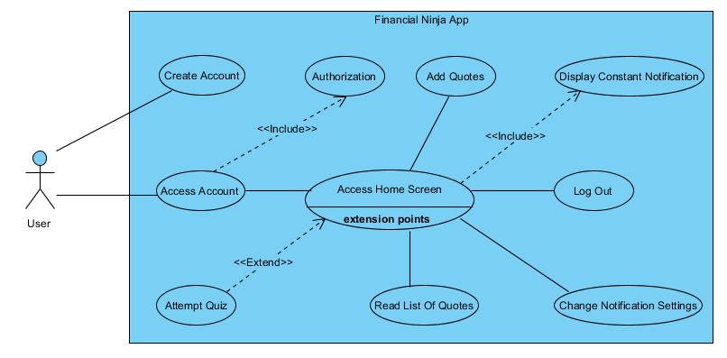

## Activity Diagram

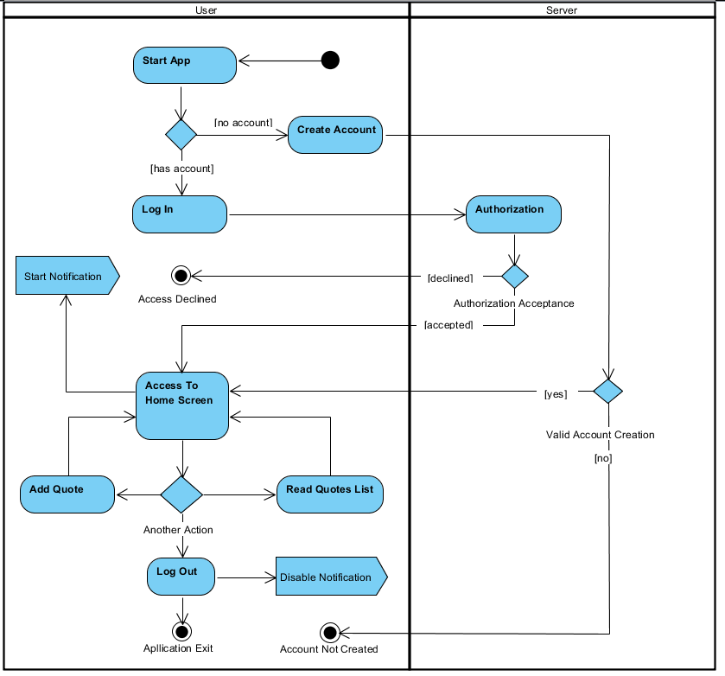

## Class Diagram

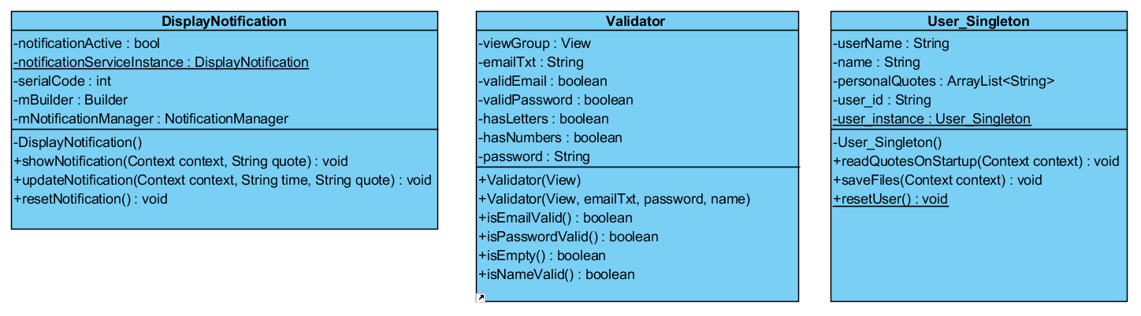

# Implementation

### Screenshots

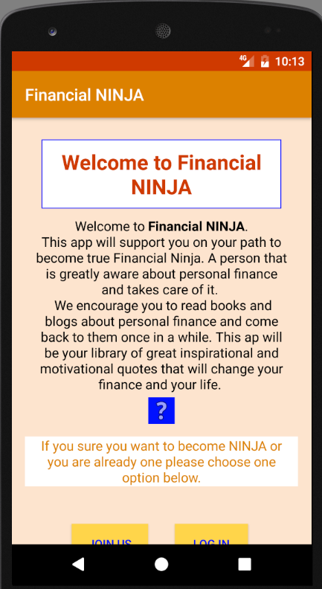 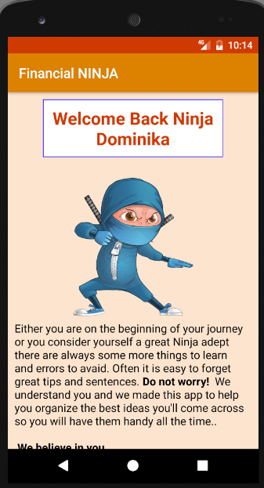 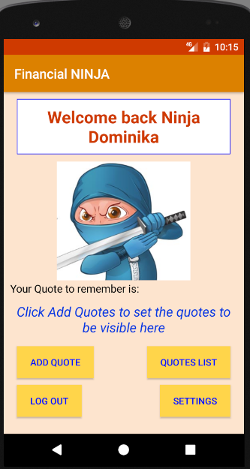

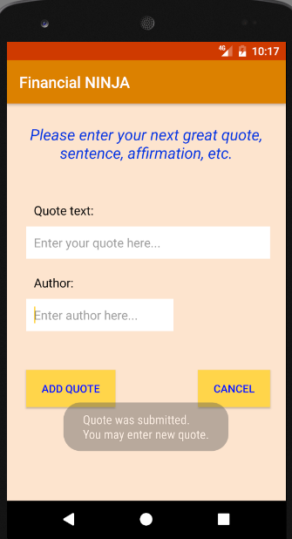 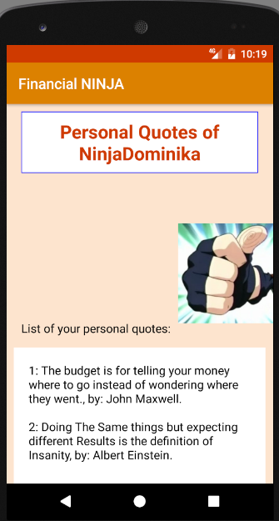 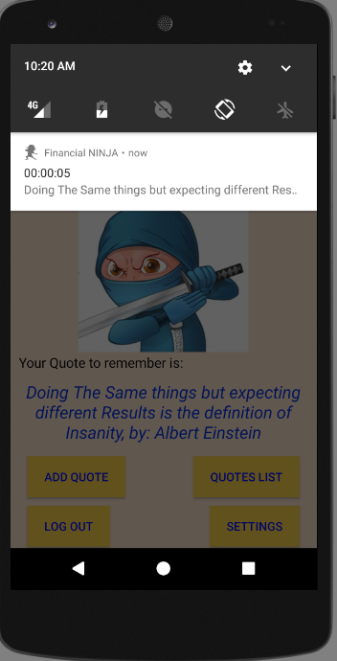

### Description

While implementing the design of the application agile methodology was used. First two weeks were spent mostly on drawings and thinking about the content of the design. This period was for requirements gathering and interviewing client. This was basically needed to find out what the project will be about and what has to be included in it. Next week was for requirements analysis and prototyping. Time was spent on designing wireframes, writing the documentation, designing activities and making the basic functionality for the app. With agile methodology this whole period was under the guidance of the client to achieve good level of understanding. The basic app prototype was created and presented to the client. The rest of the week was spent on code refactoring.

From this point the proper development starts with one week sprints ending on meeting with the client. This is required for the acceptance of the current progress and code and design refactoring. If client decides there is some additional functionality required, this might be implemented in the next sprint.

First 2 sprints were focusing mostly on creating account and login activities. Volley library was used to provide these features. More information can be found here3. There were issues with proper parameters passing between the app, PHP and into MySQL. This was caused by poor choice of hosting services. Fortunately, this was solved with the testing of account creation and login through the webpage on a more reliable hosting service.

After careful consideration of the design and the idea behind the app, the difficult decision was made by the client to abandon current project and team switched to a different one. During the design of a new project and basic implementation, client came back with new idea about the way that Financial NINJA could look like and what it could offer. To test the possible overhaul of the app and its content project files were copied and reasonable time was spent on the alterations to decide if this will bring the promising results. With most inspirational outcome, the project was reborn and new sprint started to focus on the changes and implementing new ideas.

Third sprint focused on overhaul of the project and rebuilding UI to match the needs of the new ideas. Work was scheduled as redesigning each activity and implementing the code for the basic functionality. With confirmed testing, next activity was on focus. When the new features were implemented team started the transition to prepare proper code implementation preceded by thorough refactoring to get rid of previous concept’s legacy code.

Last week was started by code refactoring. Team was focused on implementing the notification display and worked on final touches to the app. This was also the time for rework on the documentation and focusing on closing the project.

# Evaluation

### Comparison against original concept

Original concept of the application was entirely different than the final outcome. It could be debated this is actually entirely different application and only one thing that connects it to the original idea is the name and inspiration behind it. Similarities are the design and the look of the application. All screens before the main one where the quotes are displayed look exactly the same and user go through in the same order. Descriptions were changed to match the new concept.

### Comparison against similar apps

One of the promising motivational quotes applications is “Best Motivational Quotes App”5. It contains plenty of useful features for the users and allows various interactions. It allows customization as well. Comparing to Financial Ninja it presents itself with very clear and easy to use design and User Interface. It offers quotes in many different categories and allows to download and use wallpapers with those quotes. On the other hand, it doesn’t allow to display those quotes to you permanently any other way than using them as a wallpaper. It also doesn’t allow to set any time base rotation for changing the range of available quotes.

### Possible improvements

* + More animations and better look and design
  + Button to skip current quote displayed and move to the next one
  + Button to shuffle quotes
  + Edit, add and remove quotes altogether on the same screen where is the quotes list
  + Export and import of the quotes
  + Share options with other users. Share one quote or all of them.
  + Quotes displayed on top of every screen available to the user after login.
  + Read each user’s quotes from the database directly

# Resources and references

1. Książka "Finansowy ninja". (2017). *"Finansowy ninja" - podręcznik finansów osobistych*. [online] Available at: http://finansowyninja.pl/ [Accessed 6 Feb. 2017].
2. Fluidui.com. (2017). *Fluid UI - Mobile app prototyping for iPhone, iPad, Android and Windows 8*. [online] Available at: https://www.fluidui.com/editor/live/ [Accessed 6 Feb. 2017]. <https://www.fluidui.com/editor/live/comment/cF9UV29iOUprSFRaeEl3THJvVFJ6cVp1M3R6a2dSSENjVg>==
3. Volley, Transmitting. "Transmitting Network Data Using Volley | Android Developers". *Developer.android.com*. N.p., 2017. Web. 19 Mar. 2017.
4. Dave Ramsey Web Services, B. (2017). *The Total Money Makeover*. [online] Daveramsey.com. Available at: http://www.daveramsey.com/store/the-total-money-makeover/prodtmmoclassic.html [Accessed 20 Mar. 2017].
5. https://play.google.com/store/apps/details?id=com.motivetown.app

## Images used:

* Miassetmarketing.com. (2017). *Cite a Website - Cite This For Me*. [online] Available at: http://miassetmarketing.com/wp-content/uploads/2015/05/Business-Ninja.jpg [Accessed 7 Feb. 2017].
* Clipartkid.com. (2017). *Cite a Website - Cite This For Me*. [online] Available at: http://www.clipartkid.com/images/118/lego-ninjago-kai-symbol-dilX8m-clipart.jpg [Accessed 7 Feb. 2017].
* S-media-cache-ak0.pinimg.com. (2017). *Cite a Website - Cite This For Me*. [online] Available at: https://s-media-cache-ak0.pinimg.com/236x/84/6f/0b/846f0b86d125146f2d68bd61e1dc88e5.jpg [Accessed 7 Feb. 2017].
* Keywordsuggest.org. (2017). *ninja cartoon characters Gallery*. [online] Available at: http://keywordsuggest.org/gallery/311479.html [Accessed 7 Feb. 2017].
* Dantheninja.files.wordpress.com. (2017). *Cite a Website - Cite This For Me*. [online] Available at: https://dantheninja.files.wordpress.com/2009/07/thumbs-up-ninja.jpg?w=510 [Accessed 10 Feb. 2017].

## Code suggestions:

* Password string validation – from the course’s workbook
* Email string validation - address?, H. (2017). *How should I validate an e-mail address?*. [online] Stackoverflow.com. Available at: http://stackoverflow.com/questions/1819142/how-should-i-validate-an-e-mail-address [Accessed 10 Feb. 2017].
* Checking if all user input boxes are filled in - layout?, H. (2017). *How to check for empty EditText in all sublayouts of main layout?*. [online] Stackoverflow.com. Available at: http://stackoverflow.com/questions/25131647/how-to-check-for-empty-edittext-in-all-sublayouts-of-main-layout [Accessed 13 Feb. 2017].
* Account Creation and Login - YouTube. (2017). *NEW Login & Register Android App Tutorial - YouTube*. [online] Available at: https://www.youtube.com/playlist?list=PLe60o7ed8E-TztoF2K3y4VdDgT6APZ0ka [Accessed 15 Feb. 2017].
* How to check if service is already running - Android?, H. (2017). *How to check if a service is running on Android?*. [online] Stackoverflow.com. Available at: http://stackoverflow.com/questions/600207/how-to-check-if-a-service-is-running-on-android [Accessed 15 Mar. 2017].
* How to run service in Foreground - service?, A. (2017). *Android - implementing startForeground for a service?*. [online] Stackoverflow.com. Available at: http://stackoverflow.com/questions/6397754/android-implementing-startforeground-for-a-service [Accessed 15 Mar. 2017].
* How to use Put Extra with intent - data, H. (2017). *How to use putExtra() and getExtra() for string data*. [online] Stackoverflow.com. Available at: http://stackoverflow.com/questions/5265913/how-to-use-putextra-and-getextra-for-string-data [Accessed 15 Mar. 2017].

## Time spent on Project:

**19/01/2017 - 05/02/2017:** 6,5 hours – design, requirements analysis and documentation, main activity prototype, UML Diagrams

**06/02/2017 - 09/02/2017:** 6,5 hours – wireframes, design and documentation, references and brief description, activities prototyping, code refactoring, requirements analysis, planning, refactoring, updating documentation

1st Week Sprint

**10/02/2017 - 18/02/2017:** 7 hours – documentation, design, planning, login/creating account

2nd Week Sprint

**21/02/2017 – 28/02/2017:** 3,5 hours – documentation overview, design, planning, login/creating account, password validation and encryption

3rd Week Sprint

**06/03/2017 – 12/03/2017** 6 hours – Additional classes and expansion of the app to provide quote submission functionality. Created PHP file for quotes submission request, table in the database and applied adding quote functionality to the application. Worked on foreground service to display constant notification.

4th Week Sprint

**12/03/2017 – 19/03/2017** 8 hours – Completed expansion of the app. Filled in with comments, code refactoring. Foreground service idea abandoned. Notification displayed from separate class. Testing and documentation.

## ORIGINAL CONCEPT’S DIAGRAMS

